**CHAPTER 1**

**PHOTOVOLTAIC POWER SYSTEMS**

**1.1 INTRODUCTION**

**T**oday photovoltaic (PV) power systems are becoming more and more popular, with the increase of energy demand and the concern of environmental pollution around the world. Four different system configurations are widely developed in grid-connected PV power applications: the centralized inverter system, the string inverter system, the multistring inverter system and the module-integrated inverter system. Generally three types of inverter systems except the centralized inverter system can be employed as small-scale distributed generation (DG) systems, such as residential power applications. The most important design constraint of the PV DG system is to obtain a high voltage gain. For a typical PV module, the open-circuit voltage is about 21 V and the maximum power point (MPP) voltage is about 16 V. And the utility grid is 220 or 110 Vac. Therefore, the high voltage amplification is obligatory to realize the grid-connected function and achieve the low total harmonic distortion (THD). The conventional system requires large numbers of PV modules in series, and the normal PV array voltage is between 150 and 450 V, and the system power is more than 500 W. This system is not applicable to the module-integrated inverters, because the typical power rating of the module-integrated inverter system is below 500 W, and the modules with power ratings between 100 and 200 W are also quite common. The other method is to use a line frequency step-up transformer, and the normal PV array voltage is between 30 and 150 V. But the line frequency transformer has the disadvantages of larger size and weight. In the grid-connected PV system, power electronic inverters are needed to realize the power conversion, grid interconnection, and control optimization. Generally, gird-connected pulse width modulation (PWM) voltage source inverters (VSIs) are widely applied in PV systems, which have two functions at least because of the unique features of PV modules. First, the dc-bus voltage of the inverter should be stabilized to a specific value because the output voltage of the PV modules varies with temperature, irradiance, and the effect of maximum power-point tracking (MPPT). Second, the energy should be fed from the PV modules into the utility grid by inverting the dc current into a sinusoidal waveform synchronized with utility grid. Therefore, it is clear that for the inverter-based PV system, the conversion power quality including the low THD, high power factor, and fast dynamic response, largely depends on the control strategy adopted by the grid-connected inverters. In this paper, a grid-connected PV power system with high voltage gain is proposed. The steady-state model analysis and the control strategy of the system are presented. The grid connected PV system includes two power-processing stages:

a high step-up ZVT-interleaved boost converter for boosting a low voltage of PV array up to the high dc-bus voltage, which is not less than grid voltage level; and a full-bridge inverter for inverting the dc current into a sinusoidal waveform synchronized with the utility grid. Furthermore, the dc–dc converter is responsible for the MPPT and the dc–ac inverter has the capability of stabilizing the dc-bus voltage to a specific value. The grid-connected PV power system can offer a high voltage gain and guarantee the used PV array voltage is less than 50 V, while the power system interfaces the utility grid. On the one hand, the required quantity of PV modules in series is greatly reduced. And the system power can be controlled in a wide range from several hundred to thousand watts only by changing the quantity of PV module branches in parallel. Therefore, the proposed system can not only be applied to the string or multi string inverter system, but also to the module-integrated inverter system in low power applications. On PV systems employing neutral-point-clamped (NPC) topology, highly efficient reliable inverter concept (HERIC) topology, H5 topology, etc., have been widely used especially in Europe. Although the transformer less system having a floating and non earth-connected PV dc bus requires more protection, it has several advantages such as high efficiency, lightweight, etc. Therefore, the nonisolation scheme in this paper is quite applicable by employing the high step-up ZVT-interleaved boost converter, because high voltage gain of the converter ensures that the PVarray voltage is below50Vand benefits the personal safety even if in high-power application.

**1.1.1 Photovoltaic modules**

Due to the low voltage of an individual [solar cell](http://en.wikipedia.org/wiki/Solar_cell) (typically ca. 0.5V), several cells are wired in series in the manufacture of a "laminate". The laminate is assembled into a protective weatherproof enclosure, thus making a photovoltaic module or [solar panel](http://en.wikipedia.org/wiki/Solar_panel). Modules may then be strung together into a photovoltaic array. The electricity generated can be either stored, used directly (island/standalone plant)or fed into a large electricity grid powered by central generation plants (grid-connected/grid-tied plant) or combined with one or many domestic electricity generators to feed into a small grid (hybrid plant). Depending on the type of application, the rest of the system ("[balance of system](http://en.wikipedia.org/wiki/Balance_of_system)" or "BOS") consists of different components. The BOS depends on the load profile and the system type. Systems are generally designed in order to ensure the highest energy yield for a given investment.

**1.1.2 Photovoltaic arrays**

The power that one module can produce is seldom enough to meet requirements of a home or a business, so the modules are linked together to form an array. Most PV arrays use an [inverter](http://en.wikipedia.org/wiki/Solar_inverter) to convert the DC power produced by the modules into [alternating current](http://en.wikipedia.org/wiki/Alternating_current) that can power [lights](http://en.wikipedia.org/wiki/Light), motors, and other loads. The modules in a PV array are usually first connected in [series](http://en.wikipedia.org/wiki/Series_and_parallel_circuits#Series_circuits) to obtain the desired [voltage](http://en.wikipedia.org/wiki/Voltage); the individual strings are then connected in [parallel](http://en.wikipedia.org/wiki/Series_and_parallel_circuits#Parallel_circuits) to allow the system to produce more [current](http://en.wikipedia.org/wiki/Electric_current). Solar arrays are typically measured under STC (Standard Test Conditions) or PTC (PVUSA Test Conditions), in [watts](http://en.wikipedia.org/wiki/Watt), kilowatts, or even megawatts. Costs of production have been reduced in recentyears for more widespread use through production and technological advances. One source claims the cost in February 2006 ranged $3–10/watt while a similar size is said to have cost $8–10/watt in February 1996, depending on type.[[2]](http://en.wikipedia.org/wiki/Photovoltaic_system#cite_note-RISE-1) For example, crystal silicon [solar cells](http://en.wikipedia.org/wiki/Solar_cell) have largely been replaced by less expensive multi crystalline silicon solar cells, and thin film silicon solar cells have also been developed recently at lower costs of production. Although they are reduced in energy conversion efficiency from single crystalline "siwafers", they are also much easier to produce at comparably lower costs.

## 1.2 Applications

[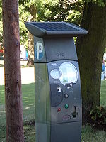](http://en.wikipedia.org/wiki/File:TicketParkingMeter.jpg)

Fig 1.1 Solar powered parking meter.

A standalone system does not have a connection to the electricity "mains" (aka "grid"). Standalone systems vary widely in size and application from wristwatches or calculators to remote buildings or spacecraft. If the load is to be supplied independently of solar [insolation](http://en.wikipedia.org/wiki/Insolation), the generated power is stored and buffered with a battery. In non-portable applications where weight is not an issue, such as in buildings, [lead acid batteries](http://en.wikipedia.org/wiki/Lead_acid_battery) are most commonly used for their low cost. A charge controller may be incorporated in the system to: a) avoid battery damage by excessive charging or discharging and, b) optimizing the production of the cells or modules by [maximum power point tracking](http://en.wikipedia.org/wiki/Maximum_power_point_tracking) (MPPT). However, in simple PV systems where the PV module voltage is matched to the battery voltage, the use of MPPT electronics is generally considered unnecessary, since the battery voltage is stable enough to provide near-maximum power collection from the PV module. In small devices (e.g. calculators, parking meters) only [direct current](http://en.wikipedia.org/wiki/Direct_current) (DC) is consumed. In larger systems (e.g. buildings, remote water pumps) AC is usually required. To convert the DC from the modules or batteries into AC, an [inverter](http://en.wikipedia.org/wiki/Inverter_(electrical)) is used.

[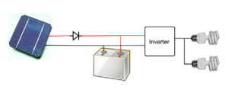](http://en.wikipedia.org/wiki/File:PV-system_log_cabin.png)

A schematic of a bare-bones off-grid system, consisting (from left to right) of photovoltaic module, a blocking-[diode](http://en.wikipedia.org/wiki/Diode) to prevent battery drain during low-insolation, a battery, an inverter, and an AC load such as a fluorescent lamp

[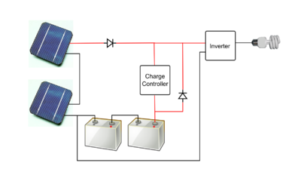](http://en.wikipedia.org/wiki/File:PV-system_country_home1.png)

Fig 1.2 off-grid PV system with battery charger

**1.3 Solar vehicles:**

Ground, water, air or space vehicles may obtain some or all of the energy required for their operation from the sun. Surface vehicles generally require higher power levels than can be sustained by a practically-sized solar array, so a battery is used to meet peak power demand, and the solar array recharges it. Space vehicles have successfully used solar photovoltaic systems for years of operation, eliminating the weight of fuel or primary batteries.

### 1.3.1 Small scale DIY solar systems

With a growing [DIY](http://en.wikipedia.org/wiki/Do_it_yourself)-community and an increasing interest in environmentally friendly "[green energy](http://en.wikipedia.org/wiki/Green_energy)", some [hobbyists](http://en.wikipedia.org/wiki/Hobby) have endeavored to build their own PV solar systems from kits or partly diy. Usually, the DIY-community uses inexpensive and/or high efficiency systems (such as those with [solar tracking](http://en.wikipedia.org/wiki/Solar_tracking)) to generate their own power. As a result, the DIY-systems often end up cheaper than their commercial counterparts. Often, the system is also hooked up unto the regular [power grid](http://en.wikipedia.org/wiki/Power_grid) to repay part of the investment via [net metering](http://en.wikipedia.org/wiki/Net_metering). These systems usually generate power amount of ~2 kW or less. Through the internet, the community is now able to obtain plans to construct the system (at least partly DIY) and there is a growing trend toward building them for domestic requirements. The DIY-PV solar systems are now also being used both in developed countries and in [developing countries](http://en.wikipedia.org/wiki/Developing_countries), to power residences and small businesses.

### 1.3.2 Grid-connected system

[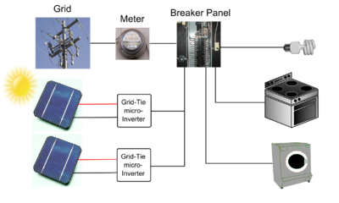](http://en.wikipedia.org/wiki/File:PV-system_urban_home1.png)

Fig 1.3 Diagram of a residential grid-connected PV system

A grid connected system is connected to a large independent grid (typically the public electricity grid) and feeds power into the grid. Grid connected systems vary in size from residential (2-10kWp) to solar power stations (up to 10s of GWp). This is a form of decentralized electricity generation. In the case of residential or building mounted grid connected PV systems, the electricity demand of the building is met by the PV system. Only the excess is fed into the grid when there is an excess. The feeding of electricity into the grid requires the transformation of DC into AC by a special, grid-controlled [inverter](http://en.wikipedia.org/wiki/Inverter_(electrical)).

In kW sized installations the DC side system voltage is as high as permitted (typically 1000V except US residential 600V) to limit ohmic losses. Most modules (72 crystalline silicon cells) generate about 160W at 36 volts. It is sometimes necessary or desirable to connect the modules partially in parallel rather than all in series. One set of modules connected in series is known as a 'string'.

### 1.3.3 Building systems

In urban and suburban areas, photovoltaic arrays are commonly used on rooftops to supplement power use; often the building will have a connection to the [power grid](http://en.wikipedia.org/wiki/Power_grid), in which case the energy produced by the PV array can be sold back to the [utility](http://en.wikipedia.org/wiki/Utility) in some sort of [net metering](http://en.wikipedia.org/wiki/Net_metering) agreement. [Solar trees](http://en.wikipedia.org/wiki/Solar_tree) are arrays that, as the name implies, mimic the look of trees, provide shade, and at night can function as [street lights](http://en.wikipedia.org/wiki/Street_light). In [agricultural](http://en.wikipedia.org/wiki/Agriculture) settings, the array may be used to directly power DC [pumps](http://en.wikipedia.org/wiki/Pump), without the need for an [inverter](http://en.wikipedia.org/wiki/Inverter_(electrical)). In remote settings such as mountainous areas, islands, or other places where a power grid is unavailable, solar arrays can be used as the sole source of electricity, usually by charging a [storage battery](http://en.wikipedia.org/wiki/Storage_battery). There is financial support available for people wishing to install PV arrays. In the UK, households are paid a 'Feedback Fee' to buy excess electricity at a flat rate per kWh. This is up to 44.3p/kWh which can allow a home to earn double their usual annual domestic electricity bill. The current UK feed-in tariff system is due for review on 31 March 2012, after which the current scheme may no longer be available.

### 1.4 Power plants

[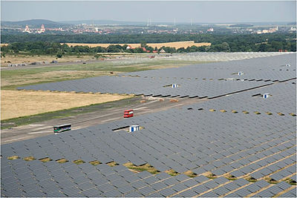](http://en.wikipedia.org/wiki/File:Juwi_PV_Field.jpg)

Fig 1.4 [Waldpolenz Solar Park](http://en.wikipedia.org/wiki/Waldpolenz_Solar_Park), [Germany](http://en.wikipedia.org/wiki/Germany)

A photovoltaic power station is a [power station](http://en.wikipedia.org/wiki/Power_station) using photovoltaic modules and [inverters](http://en.wikipedia.org/wiki/Inverter_(electrical)) for utility scale [electricity generation](http://en.wikipedia.org/wiki/Electricity_generation), connected to an electricity transmission grid. Some large photovoltaic power stations like [Waldpolenz Solar Park](http://en.wikipedia.org/wiki/Waldpolenz_Solar_Park) cover a significant area and have a maximum power output of 40-60 MW.

**System performance**

At high noon on a cloudless day at the equator, the power of the sun is about 1 [kW](http://en.wikipedia.org/wiki/Kilowatt)/m², on the Earth's surface, to a plane that is perpendicular to the sun's rays. As such, PV arrays can [track the sun](http://en.wikipedia.org/wiki/Solar_tracker) through each day to greatly enhance energy collection. However, tracking devices add cost, and require maintenance, so it is more common for PV arrays to have fixed mounts that tilt the array and face due South in the Northern Hemisphere (in the Southern Hemisphere, they should point due North). The tilt angle, from horizontal, can be varied for season, but if fixed, should be set to give optimal array output during the peak electrical demand portion of a typical year. For the weather and latitudes of the United States and Europe, typical insolation ranges from 4 kWh/m²/day in northern climes to 6.5 kWh/m²/day in the sunniest regions. Typical solar panels have an average efficiency of 12%, with the best commercially available panels at 20%. Thus, a photovoltaic installation in the southern latitudes of Europe or the United States may expect to produce 1 kWh/m²/day. A typical "150 watt" solar panel is about a square meter in size. Such a panel may be expected to produce 1 kWh every day, on average, after taking into account the weather and the latitude. In the [Sahara](http://en.wikipedia.org/wiki/Sahara) desert, with less cloud cover and a better solar angle, one could ideally obtain closer to 8.3 kWh/m²/day provided the nearly ever present wind would not blow sand on the units. The unpopulated area of the Sahara desert is over 9 million km², which if covered with solar panels would provide 630 terawatts total power. The Earth's current energy consumption rate is around 13.5 TW at any given moment (including oil, gas, [coal](http://en.wikipedia.org/wiki/Coal), [nuclear](http://en.wikipedia.org/wiki/Nuclear_power), and [hydroelectric](http://en.wikipedia.org/wiki/Hydroelectric)).

### 1.4.1 Tracking the sun

Trackers and sensors to optimise the performance are often seen as optional, but tracking systems can increase viable output by up to 100%. PV arrays that approach or exceed one megawatt often use solar trackers. Accounting for clouds, and the fact that most of the world is not on the equator, and that the sun sets in the evening, the correct measure of solar power is [insolation](http://en.wikipedia.org/wiki/Insolation) – the average number of kilowatt-hours per square meter per day. For the weather and latitudes of the United States and Europe, typical insolation ranges from 4kWh/m²/day in northern climes to 6.5 kWh/m²/day in the sunniest regions. For large systems, the energy gained by using tracking systems outweighs the added complexity (trackers can increase efficiency by 30% or more).

### 1.4.2 Shading and dirt

Photovoltaic cell electrical output is extremely sensitive to shading. When even a small portion of a cell, module, or array is shaded, while the remainder is in sunlight, the output falls dramatically due to internal 'short-circuiting' (the electrons reversing course through the shaded portion of the [p-n junction](http://en.wikipedia.org/wiki/P-n_junction)). If the current drawn from the series string of cells is no greater than the current that can be produced by the shaded cell, the current (and so power) developed by the string is limited. If enough voltage is available from the rest of the cells in a string, current will be forced through the cell by breaking down the junction in the shaded portion. This breakdown voltage in common cells is between 10 and 30 volts. Instead of adding to the power produced by the panel, the shaded cell absorbs power, turning it into heat. Since the reverse voltage of a shaded cell is much greater than the forward voltage of an illuminated cell, one shaded cell can absorb the power of many other cells in the string, disproportionately affecting panel output. For example, a shaded cell may drop 8 volts, instead of adding 0.5 volts, at a particular current level, thereby absorbing the power produced by 16 other cells. Therefore it is extremely important that a PV installation is not shaded at all by trees, architectural features, flag poles, or other obstructions. Most modules have bypass diodes between each cell or string of cells that minimize the effects of shading and only lose the power of the shaded portion of the array (The main job of the bypass diode is to eliminate hot spots that form on cells that can cause further damage to the array, and cause fires.). Sunlight can be absorbed by dust, snow, or other impurities at the surface of the module. This can cut down the amount of light that actually strikes the cells by as much as half. Maintaining a clean module surface will increase output performance over the life of the module.

### 1.4.3 Temperature

Module output and life are also degraded by increased temperature. Allowing ambient air to flow over, and if possible behind, PV modules reduces this problem.

### 1.4.4 Module efficiency

In 2010, solar panels available for consumers can have a yield of up to 19%, while commercially available panels can go as far as 27%. Thus, a photovoltaic installation in the southern latitudes of Europe or the United States may expect to produce 1 kWh/m²/day. A typical "150 watt" solar panel is about a square meter in size. Such a panel may be expected to produce 1 kWh every day, on average, after taking into account the weather and the latitude. Module life Effective module lives are typically 25 years or more.

## 1.5 Components

## Tracker

## A [solar tracker](http://en.wikipedia.org/wiki/Solar_tracker) tilts a solar panel throughout the day. Depending on the type of tracking system, the panel is either aimed directly at the sun or the brightest area of a value. Because most [concentrated photovoltaics](http://en.wikipedia.org/wiki/Concentrated_photovoltaics) systems are very sensitive to the sunlight's angle, tracking systems allow them to produce useful power for more than a brief period each day.

## Tracking systems improve performance for two main reasons. First, when a solar panel is perpendicular to the sunlight, the light it receives is more intense than it would be if angled.

## Second, direct light is used more efficiently than angled light..

### 1.5.1 Inverters

[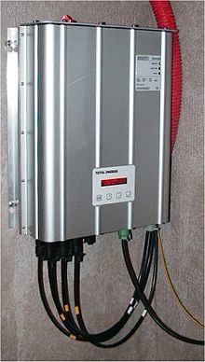](http://en.wikipedia.org/wiki/File:Onduleur_pour_photovolta%C3%AFque.jpg)

Fig 1.5 Inverter for grid connected PV

On the AC side, these inverters must supply electricity in sinusoidal form, synchronized to the grid frequency, limit feed in voltage to no higher than the grid voltage including disconnecting from the grid if the grid voltage is turned off.

[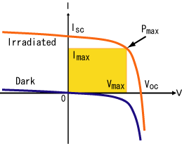](http://en.wikipedia.org/wiki/File:SolarCell-IVgraph3-E.PNG)

On the DC side, the power output of a module varies as a function of the voltage in a way that power generation can be optimized by varying the system voltage to find the 'maximum power point'. Most inverters therefore incorporate 'maximum power point tracking'. A [solar inverter](http://en.wikipedia.org/wiki/Solar_inverter) may connect to a string of solar panels. In small installations a [solar micro-inverter](http://en.wikipedia.org/wiki/Solar_micro-inverter) is connected at each solar panel. For safety reasons a circuit breaker is provided both on the AC and DC side to enable maintenance. AC output may be connected through an [electricity meter](http://en.wikipedia.org/wiki/Electricity_meter) into the public grid. The meter must be able to run in both directions. In some countries, for installations over 30kWp a frequency and a voltage monitor with disconnection of all phases is required.

### 1.5.2 Mounting systems

[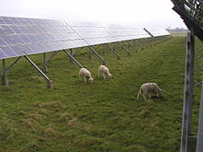](http://en.wikipedia.org/wiki/File:Pellworm_Solarkraftanlage_MS_P4140080.JPG)

Fig 1.6 Ground mounted system

Modules are assembled into arrays on some kind of mounting system. For solar parks a large rack is mounted on the ground, and the modules mounted on the rack. For buildings, many different racks have been devised for pitched roofs. For flat roofs, racks, bins and building integrated solutions are used.

## 1.5.3 Connection to a DC grid

DC grids are only to be found in electric powered transport: railways trams and trolleybuses. A few pilot plants for such applications have been built, such as the tram depots in Hannover Leinhausen and Geneva (Bachet de Pesay). The 150 kWp Geneva site feeds 600V DC directly into the tram/trolleybus electricity network provided about 15% of the electricity at its opening in 1999.

## 1.6 Hybrid systems

[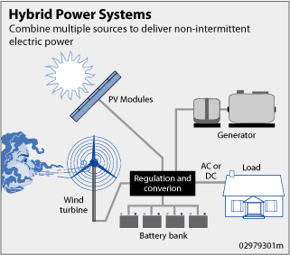](http://en.wikipedia.org/wiki/File:Hybrid_Power_System.gif)

Fig 1.7 Hybrid Power Systems

A hybrid system combines PV with other forms of generation, usually a diesel generator. Biogas is also used. The other form of generation may be a type able to modulate power output as a function of demand. However more than one renewable form of energy may be used e.g. wind. The photovoltaic power generation serves to reduce the consumption of non renewable fuel. Hybrid systems are most often found on islands. [Pellworm](http://en.wikipedia.org/wiki/Pellworm) island in Germany and [Kythnos](http://en.wikipedia.org/wiki/Kythnos) island in Greece are notable examples (both are combined with wind). The Kythnos plant has diocane diesel consumption by 11.2%. There has also been recent work showing that the PV penetration limit can be increased by deploying a distributed network of PV+CHP hybrid systems in the U.S. The temporal distribution of solar flux, electrical and heating requirements for representative U.S. single family residences were analyzed and the results clearly show that hybridizing CHP with PV can enable additional PV deployment above what is possible with a conventional centralized electric generation system. This theory was reconfirmed with numerical simulations using per second solar flux data to determine that the necessary battery backup to provide for such a hybrid system is possible with relatively small and inexpensive battery systems. In addition, large PV+CHP systems are possible for institutional buildings, which again provide back up for intermittent PV and reduce CHP runtime.

**CHAPTER 2**

**DC-DC CONVERTERS**

* 1. **LITERATURE REVIEW**

DC-DC converters are an important component as power electronics interfaces for photovoltaic generators and other renewable energy sources. Most renewable power sources, such as photovoltaic power systems and fuel cells, have quite low-voltage output and require series connection or a voltage booster to provide enough voltage output. Boost converters are popularly employed in equipments for different applications, as pre regulators or even integrated with the latter-stage circuits or rectifiers into single-stage circuits. Interleaved method used to improve power converter performance in terms of efficiency, size, conducted electromagnetic emission, and transient response. The benefits of interleaving include high power capability, modularity, and improved reliability. However, an interleaved topology improves converter performance at the cost of additional inductors, power switching devices, and output rectifiers. The power loss in a magnetic component decreases when the size of the inductor increases though both the low power loss and small volume are required. This means that there is a trade-off relationship between the power loss and the magnetic component size. Therefore, the design of magnetic components in converters is one of the important challenging problems. There are several well-known strategies for selecting a core for the design of magnetic components, for example, the area product (*Ap*) method and the core geometry (*Kg*) method. The *Ap* method is widely used for designing the inductors and transformers for dc-dc power converters operating in CCM and DCM. On the other hand, the concept of the *Kg* approach is to select a proper core satisfying the electromagnetic conditions, the restriction of the core window area, and the restriction of the winding loss, simultaneously. This method is useful to design inductors and transformers with low core and ac winding losses.

**2.2.INTERLEAVED OPERATION**



Figure 2.1. Two-phase interleaved boost converter

The interleaved boost converters consists of several identical boost converters connected in parallel and controlled by the interleaved method which has the same switching frequency and phase shift. Ripple cancellation both in the input-output voltage and current waveforms, reduced current peak value, and high ripple frequency are some of the benefits of interleaving operation in converters. Moreover, increased efficiency and high reliability can be achieved. Also, by high frequency, the size and losses of the magnetic components can be reduced. These interleaved boost converters are distinguished similar with conventional converters by critical operation mode, discontinuous conduction mode (DCM), and continuous conduction mode (CCM). In critical operation mode, filter design is more difficult because critical point vary by load. In the DCM, although the disadvantages related to the reverse recovery effects(RREs) of boost diodes are improved, there are advantages such as high input peak current and conduction losses. However, DCM generally undesirable for highpower applications. Interleaved boost converters operating in CCM have better utilization of power devices, lower conduction losses, and lower input peak current. Highpower applications are easily achieved with CCM. Two-phase interleaved boost topology is given at Figure 2.1. After, S1 turns-on, iL1 current increase linearly. In this interval energy stored in L1. At Figure 2.2, it can be seen that the input current, *i*, for two-phase interleaved boost converter is the sum of each channels inductor currents. Because signals are 180° phaseshifted, the input current ripple produced is the smallest.



Figure 2.2. Ideal waveforms of the currents in the inductors *L1* and *L2* for interleaved boost converter operating at CCM.

**2.2.INDUCTOR DESIGN**

The design of magnetic components in converters is one of the important problems. To design an inductor for a DCDC converter, desired inductance, *L*, the dc current flows through inductance, *Idc*, current ripple on inductance, *􀇻IL*, and power loss parameters should be given. Operating frequency is essential parameter when selecting the material of magnetic core. Core geometry(*Kg*) and Area Product(*Ap*) approaches are two methods for selecting core. These methods are primarily used in the design of inductors for switching-mode power supplies (SMPS). In this paper, core geometry approach used to select magnetic core. For interleaved operation two identical boost converter parallel connected and operated with 180° phase shifted. Designed inductor will used for both phases.

*A. Core Selection*

Inductors are designed for a given regulation,α

 (2.1)

desired to be %1. In (2.1), E is energy handling capability of magnetic core and calculated by,

 (2.2)

*Ke* is electrical conditions coefficient and depend on output power, *Po* and operating flux density *Bm*

****(2.3)

In (2.1), the other constant that energy and regulation related is core geometry coefficient, *Kg*,

 (2.4)

*Kg*, is related with, window area of core, *Wa*, iron area of core, *Ac*, window utilization factor, *Ku*, and mean length turn, *MLT*. These parameters are depend on core shapes and types. From (2.1), *Kg* is,

** (**2.5)

After calculating core geometry coefficient, suitable inductor cores shape and type are defined from the standard design data tables of magnetic

**B. Wire Selection**

Before wire area calculation, current density, J, should defined. It should be noted that, at Area Product approach current density is estimated, but in Core Geometry approach current density is calculated.

** (2.6)**

In (2.6), *Ap* is area product and wire area, *Aw* is given by

** (2.7)**

With the calculated *Aw*, wire is selected from wire standards.

*C. Air Gap Length*

The inductance value is adjusted by the air-gap length.

**(2.8)**

MPL is magnetic path length and *μμ* is permeability of core material. In (8), N is number of turns. But to define actual number of turns, fringing flux at the air gap should be known. So possible number of turns is used to calculate airgap length and given by effective window area, Wa(eff),

** (2.9)**

Effective window area is the product of window area and effective window factor. Effective window factor defines how much of the available window space may actually be used for the winding and generally 0.75 is a good value for design. SF, is fill factor.

D. Number of turns:

Fringing flux can reduce the overall efficiency of the converter, by generating eddy currents that cause localized heating in the windings. When designing inductors, fringing flux must to be taken into consideration. Fringing flux factor is,

** (2.10)**

G is winding length. With considering the effect of fringing factor, real number of turns is,

**(2.11)**

**CHAPTER-3**

**PROPOSED CONCEPT**

**3.1. Introduction**

Fossil fuels are energy sources such as coal, oil and natural gas. The world virtually depends on the supply of fossil-fuel for energy. But the common issue is that fossil-fuels are running out. It would take millions of years to completely restore the fossil fuels that we have used in just a few decades. This means fossil fuels are non-renewable sources of energy. Renewable energy comes in as a resolution for this global issue. Renewable energy is any natural source that can replenish itself naturally over a short amount of time. Renewable energy comes from many commonly known sources such as solar power, wind, running water and geothermal energy. Renewable energy sources are wonderful options because they are limitless. Also another great benefit from using renewable energy is that many of them do not pollute our air and water, the way burning fossil fuels does. Any such renewable energy system requires a suitable converter to make it efficient. Interleaved boost converter is one such converter that can be used for these applications. The Interleaved boost converter has high voltage step up, reduced voltage ripple at the output, low switching loss, reduced electromagnetic interference and faster transient response. Also, the steady-state voltage ripples at the output capacitors of mc are reduced. Though IBC topology has more inductors increasing the complexity of the converter compared to the conventional boost converter it is preferred because of the low ripple content in the input and output sides. In order to reduce this complexity, this paper investigates the benefits of coupled, uncoupled and inversely inductors for mc. Detailed analysis has been done to study the ripple content of all the three types of the converter. The suitable mc for fuel cell applications is proposed. Gating pulses are generated using pulse generator. Simulations have been performed to validate the concepts.

Most renewable sources energy sources such as fuel cells and photovoltaic cells have received a worldwide great attention in research fields, there is renewed focus on the power electronic converter interface for DC energy sources. These power sources have quite low -voltage output and require series connection of voltage booster to provide enough voltage output. DC-DC boost converter is generally used to further boost the voltage to the required level. Various other boosters such as boost, buck-boost series resonant full-bridge and push-pull converters are not recommended because they add objectionable ripples in the current flowing out of the fuel cell. To minimize the ripples, an IBC has been proposed as a suitable interface for this renewable source. Two-phase boost converter operates at a very large duty cycle due to a high output voltage and a low input voltage. Interleaved method is used to improve converter performance in terms of efficiency, size, conducted electromagnetic emission and transient response. To minimize the amount of ripples, IBC has been proposed in addition to which it has improved performance characteristics of higher power capability, modularity and improved reliability. However IBC improves converter performance at the cost of additional inductors, switching devices and output rectifiers. Mathematical analysis of the current ripple and the design parameters included in this study. Simulation study has been performed to understand the efficiency of the IBC and the results have been validated. The parallel connection of boost converters in high power applications is a well-known technique. Its main advantage stems from the fact that sharing the input current among the parallel converters allows smoothing some of the design constraints of the switching cells. It also has an added advantage that the switching and conduction losses are less in interleaved boost converter than the conventional boost converter. The cancellation of low frequency harmonics eventually allows the reduction in size and losses of the filtering stages. Simulation results show that the current ripple in the input and output circuits is less and also minimizes the size of input filter and output power is more for IBC. The frequency of the current ripple is twice for two phase IBC than the conventional boost converter. Due to a phase shift of 180 degrees ripple cancellation takes place. This paper concentrates on the various design aspects, steady state and transient response, device selection, operating principle, gating pattern and the various waveforms which compares with the conventional boost converter.

The energy consumption is steadily increasing and the deregulation of electricity has caused that the amount of installed production capacity of classical high power stations cannot follow the demand. A method to fill out the gap is to make incentives to invest in renewable energy sources like wind turbines, photovoltaic systems, and also fuel cell systems. The output voltage of renewable energy sources has been changed and not enough. The developments of power converter are very important, in order to achieve a good operation for supplying the load when the main sources aren’t enough.

To transfer the energy from renewable energy sources to conventional 380 Vrms AC systems, it is necessary to step the voltage up using a DC/DC converter. The boost converter is strongly suitable for this purpose, but, to obtain a high voltage gain, the boost converter must operate with duty cycle greater than 0.95, which is very hard to achieve due to operational limitations. Besides, the converter must work in a bidirectional way, due to its two operation possibilities: as source, supplying energy to the load, helping the main sources, and as a load, storing exceeding energy. To solve the drawback of the low voltage gain in conventional boost converters, some topologies were suggested. The use of an interleaved boost converter associated with an isolated transformer was introduced, using the high frequency AC link. Despite of the good performance of such topology, it uses three magnetic cores. The converter presents low input current ripple and low voltage stress across the switches. However, high current flows through the series capacitors at high power levels. These converters present low voltage stress across the switches, but the input current is pulsed, as it needs an LC input filter. This paper will propose the design and analysis of interleaved boost converter for renewable energy sources. According to the changing of the input command of renewable energy sources, the output voltage has been changed. The structure of interleaved boost converter covers an input voltage span from 100V to 300 V and has an output voltage of 600V. The converters are controlled by interleaved switching signals, which have the same switching frequency and the same phase shift.

This paper will first explain the basic principle of renewable energy sources. Next, the operation and design of interleaved boost converter are obtained. The simulation results are also presented. Finally, a general conclusion and discussion are proposed.

**3.2RENEWABLE ENERGY SOURCES**

Three different renewable energy sources are briefly described. There are Fuel cell, wind power and photovoltaic.

**A. Fuel Cell Energy**

The fuel cell is a chemical device, which produces electricity directly without any intermediate stage and has recently received much attention. The most significant advantages are low emission of green house gases and high power density. The emission consists of only harmless gases and water. The noise emission is also low.

The energy density of a typical fuel cell is 200 Wh/l, which is nearly ten times of a battery. Various fuel cells are available for industrial use or currently being investigated for use in industry, including

⇒Proton Exchange Membrane

⇒Solid Oxide

⇒Molten Carbonate

⇒Phosphoric Acid

⇒Aqueous Alkaline

The efficiency of the fuel cell is quite high (40%- 60%). Also the waste heat generated by the fuel cell can usually be used for cogeneration such as steam, airconditioning, hot air and heating, then the overall efficiency of such a system can be as high as 80%.

**B. Photovoltaic Cell**

Photovoltaic (PV) power supplied to the utility grid is gaining more and more visibility due to many national incentives. With a continuous reduction in system cost, the PV technology has the potential to become one of the main renewable energy sources for the future electricity supply. The PV cell is an all-electrical device, which produces electrical power when exposed to sunlight and connected to a suitable load. Without any moving parts inside the PV module, the tear-and-wear is very low. Thus, lifetimes of more than 25 years for modules and easily reached. However, the power generation capability may be reduced to 75%-80% of nominal value due to ageing. A typical PV module is made up around 36 or 72 cells connected in series, encapsulated in a structure made of e.g. aluminum and tedlar. Several types of proven PV technologies exist, where the crystalline (efficiency=10%-15%) and multicrystalline (efficiency=9%-12%) silicon cells are based on standard microelectronic manufacturing processes.

Other types are: thin-film amorphous silicon

(efficiency=10%), thin-film copper indium diselenide

(efficiency=12%), and thin-film cadmium telluride

(efficiency=9%). Novel technologies such as the thin layer silicon (efficiency=8%) and the dye-sensitised

nano-structured materials (efficiency=9%) are in their early development. The reason to maintain a high level of research and development within these technologies is to decrease the cost of the PV-cells, perhaps on the expense of a somewhat lower efficiency, this is mainly due to the fact that cells based on today’s microelectronic processes are rather costly, when compared to other renewable energy sources.

C. Wind Energy

The function of a wind turbine is to convert the linear motion of the wind into rotational energy that can be used to drive a generator. Wind turbines capture the power from the wind by means of aerodynamically designed blades and convert it into rotating mechanical power. At present, the most popular wind turbine is the Horizontal Axis Wind Turbine where the number of blades is typically three. Where is the air density, R is the turbine radius, v is the wind speed and Cp is the turbine coefficient which represnts the power conversion efficiency of a wind turbine. Cp is a function of the tip-speed ratio ( ), as well as the blade pitch angle ( ) in the pitch contrlloed wind turbine. is defined as the ratio of the tip speed of the turbine blades to wind speed.

**3.3.THE PRINCIPLE OF INTERLEAVED BOOST CONVERTER**

In order to achieve the requirement of small volume, light weight, and reliable properties, a High Power Interleaved Boost Converter is constructed, as shown in fig 1.



Fig 3.1. The topology of the Interleaved Boost Converters

The principle of Interleaved Boost Converter as follows: each phase is a BOOST/BUCK DC-DC Converter, which is composed of a bridge of power switches and storage energy inductor. When S1u=S2u=OFF, S1d and S2d switch on and off, the system work in the BOOST mode, shown in Table 1.



Tab 3.1 The state of the power device in BOOST mode

From the table 1, we can see that in Boost mode, only the power devices (S1d,S2d,D1u,D2u) have switching commutation, the power devices (S1u,S2u,D1d, D2d) have no commutation. The power switches S1d and S2d have 180-degree phase difference of driving pulses in a cycle. The current fluctuation of input power supply is reduced greatly because the two 180-degree phase difference inductor currents minify the fluctuation of each other [1] [4]. In one switching cycle Ts, considering the commutation of power switches and diodes (S1d,S2d,D1u,D2u), there have eight kinds of running states，as shown in Table 3.2.



Tab 3.2. The eight kinds of running states in interleave BOOST mode

According to Tab 3.2, The converter have eight equivalent sub-circuits of state 1~state 8，as shown in Fig3. 2.



Fig 3.2a. The equivalent sub-circuits of state 1



Fig 3.2b. The equivalent sub-circuits of state 2



Fig 3.2c. The equivalent sub-circuits of state 3



Fig 3.2d. The equivalent sub-circuits of state 4



Fig 3.2e. The equivalent sub-circuits of state 5



Fig 3.2f. The equivalent sub-circuits of state 6



Fig 3.2g. The equivalent sub-circuits of state 7



Fig3.2h. The equivalent sub-circuits of state 8

**3.4 OPERATION OF IBC**

Interleaved boost converter mainly used for renewable energy sources has a number of boost converters connected in parallel which have the same frequency and phase shift. These IBC`s are distinguished from the conventional boost converters by critical operation mode, discontinuous conduction mode (DCM) and continuous conduction mode (CCM) so that the devices are turned on when the current through the boost rectifier is zero. In the critical conduction mode the design becomes tedious as the critical point varies with load. In the DCM, the difficulties of the reverse recovery effects are taken care but it leads to high input current and conduction losses and it is not best suited for high power applications. CCM has lower input peak current, less conduction losses and can be used for high power applications. By dividing the output current into ‘n’ paths higher efficiency is achieved and eventually reducing the copper losses and the inductor losses.

Here the operation of two phase interleaved boost converter is explained which is shown in the figure. Firstly when the device S1 is turned ON, the current in the inductor iL1 increases linearly. During this period energy is stored in the inductor L1. When S1 is turned OFF, diode D1 conducts and the stored energy in the inductor ramps down with a slope based on the difference between the input and output voltage. The inductor starts to discharge and transfer the current via the diode to the load. After a half switching cycle of S1, S2 is also turned ON completing the same cycle of events. Since both the power channels are combined at the output capacitor, the effective ripple frequency is twice than that of a single-phase boost converter. The amplitude of the input current ripple is small. This advantage makes this topology very attractive for the renewable sources of energy.

The gating pulses of the two devices are shifted by a phase difference of 360/n, where n is the number of parallel boost converters connected in parallel. For a two-phase interleaved boost converter n=2, which is 180 degrees and it is shown in Fig.3.3

The two phases of the converter are driven 180 degrees out of phase, this is because the phase shift to be provided depends on the number of phases given by 360/n where n stands for the number of phases.



Fig. 3.3 Circuit diagram of a two phase uncoupled IBC

Since two phases are used the ripple frequency is doubled and results in reduction of voltage ripple at the output side. The input current ripple is also reduced by this arrangement. When gate pulse is given to the first phase for a time tJ, the current across the inductor rises and energy is stored in the inductor. When the device in the first phase is turned OFF, the energy stored is transferred to the load through the output diode D. The inductor and the capacitor serve as voltage sources to extend the voltage gain and to reduce the voltage stress on the switch. The increasing current rate across the output diode is controlled by inductances in the phases. Gate pulse is given to the second phase during the time t1 to t2 when the device in the first phase is OFF. When the device in the phase two is ON the inductor charges for the same time and transfers energy to the load in a similar manner as the first phase. Therefore the two phases feed the load continuously. Fig.3.3 to 3.5 shows the schematic diagrams of the two phase interleaved boost converter with uncoupled, directly coupled and inversely coupled IBC. As the output current is divided by the number of phases, the current stress in each transistor is reduced. Each transistor is switched at the same frequency but at a phase difference of II. Switching sequences of each phase may overlap depending upon the duty ratio (D). In this case the input voltage to the IBC is 20V and the desired output voltage is 40V, therefore D has to been chosen as 0.5.



Fig.3.4 Circuit Diagram of a 2-phase directly coupled IBC



Fig. 3.5 Circuit Diagram of a two phase inversely coupled IBC

**3.5. DESIGN METHODOLOGY OF IBC**

The design methodology for all types of IBC's require a selection of proper values of inductor, capacitor and proper choice of the power, semiconductor devices to reduce the switching losses. The steps involved in designing IBC are as follows:

• Decision of duty ratio and number of phases

• Selection of Inductor values

• Selection of power semiconductor switches

• Design of output filter

**A) Selection of duty ratio and number of phases**

Two phase IBC is chosen since the ripple content reduces with increase in the number of phases. If the number of the phases is increased further, without much decrease in the ripple content, the complexity of the circuit increases very much, thereby increasing the cost of implementation. Hence, as a tradeoff between the ripple content and the cost and complexity, number of phases is chosen as two. The number of inductors, switches and diodes are same as the number of phases and switching frequency is same for all the phases.

 (3.1)





Fig. 3.6 Switching pattern for two phase IBC

The input current ripple can be zero at specific duty ratios which are multiples of lIN, where N stands for the no of phases. Here the number of phases is two therefore the duty ration is taken as 0.5. The switching pattern is shown in Figure3.6.

**B) Selection of inductors**

For the selection of the proper inductor and capacitor the design equation part for all the three converters are given below:

1. Uncoupled inductor

The value of the inductance is given by equation

 (3.2)

2. Coupled inductor

The equivalent inductance expression for directly coupled IBC is

 (3.3)

Where V in represents input voltage, D represents duty ratio. The phase current ripple which is decided by Leq is given by

 (3.4)

To find out the values of mutual inductance (LrJ, the input current is calculated using the input voltage and power . With a coupling coefficient (a) of 0.61, the minimum self- inductance of the coupled inductor is found as

 (3.5)

The value of Lm is calculated as

 (3.6)

Therefore, the overall input current ripple is derived As

 (3.7)

From the above equations it is clear that increasing the value of the coupling coefficient can effectively reduce the input current ripple, but the phase current ripple is increased . Therefore, the value of coupling coefficient is carefully chosen as 0.61, so that the input current ripple is reduced and the phase current ripples are within the limits .

**3.1nversely coupled inductor**

The self inductance value for inversely coupled is obtained from the equation below:

 (3.8)

The mutual inductance value is given by

 (3.9)

**C) Selection of Power Devices**

The semiconductor device chosen for constructing the two phase interleaved boost converter is the IGBT [10]. The main benefits of IGBT are lower on state resistance, lower conduction losses and high switching operation. The maximum voltage across the switching devices is given by

 (3.10)

Where Yin is the input voltage, D is the duty ratio of the converter. The diode has less forward voltage, high reverse breakdown voltage and less reverse recovery current which results in reduced switching loss. Due to absence of reverse recovery current, there is no need of active snubber circuit for protection. Hence the circuit complexity is reduced. Circuit reliability is improved and design of the converter is simplified.

**D) Output Filter**

A capacitor filter is needed at the output to limit the peak to peak ripple of the output voltage. The capacitance of the output filter is function of the duty cycle, frequency and minimum load resistance during maximum load [15]. For 5% output voltage ripple, the value of the capacitance is given by the formula

 (3.11)

Where R represents the load resistance, V 0 represents the output voltage and T represents the switching period.

**CHAPTER 4**

**MATLAB/SIMULATION RESULTS**

**4.1 Introduction**

MATLAB is a high-performance language for technical computing. It integrates computation, visualization, and programming in an easy-to-use environment where problems and solutions are expressed in familiar mathematical notation. Typical uses include-

* Math and computation
* Algorithm development
* Data acquisition
* Modeling, simulation, and prototyping
* Data analysis, exploration, and visualization
* Scientific and engineering graphics

MATLAB is an interactive system whose basic data element is an array that does not require dimensioning. This allows solving many technical computing problems, especially those with matrix and vector formulations, in a fraction of the time it would take to write a program in a scalar non-interactive language such as C or FORTRAN.

The MATLAB system consists of six main parts:

**(a) Development Environment**

This is the set of tools and facilities that help to use MATLAB functions and files. Many of these tools are graphical user interfaces. It includes the MATLAB desktop and Command Window, a command history, an editor and debugger, and browsers for viewing help, the workspace, files, and the search path.

**(b) The MATLAB Mathematical Function Library**

This is a vast collection of computational algorithms ranging from elementary functions, like sum, sine, cosine, and complex arithmetic, to more sophisticated functions like matrix inverse, matrix Eigen values, Bessel functions, and fast Fourier transforms.

**(c)The MATLAB Language**

This is a high-level matrix/array language with control flow statements, functions, data structures, input/output, and object-oriented programming features. It allows both "programming in the small" to rapidly create quick and dirty throw-away programs, and "programming in the large" to create large and complex application programs.

**(d) Graphics**

MATLAB has extensive facilities for displaying vectors and matrices as graphs, as well as annotating and printing these graphs. It includes high-level functions for two-dimensional and three-dimensional data visualization, image processing, animation, and presentation graphics. It also includes low-level functions that allow to fully customize the appearance of graphics as well as to build complete graphical user interfaces on MATLAB applications.

**(e)The MATLAB Application Program Interface (API)**

This is a library that allows writing in C and FORTRAN programs that interact with MATLAB. It includes facilities for calling routines from MATLAB (dynamic linking), calling MATLAB as a computational engine, and for reading and writing MAT-files.

**(f) MATLAB Documentation**

MATLAB provides extensive documentation, in both printed and online format, to help to learn about and use all of its features. It covers all the primary MATLAB features at a high level, including many examples. The MATLAB online help provides task-oriented and reference information about MATLAB features. MATLAB documentation is also available in printed form and in PDF format.

**(g) Mat lab tools**

(i) Three phase source block

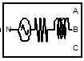



The Three-Phase Source block implements a balanced three-phase voltage source with internal R-L impedance. The three voltage sources are connected in Y with a neutral connection that can be internally ground.

(ii**) VI measurement block**

The Three-Phase V-I Measurement block is used to measure three-phase voltages and currents in a circuit. When connected in series with three-phase elements, it returns the three phase-to-ground or phase-to-phase voltages and the three line currents

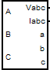



(iii) **Scope**

Display signals generated during a simulation. The Scope block displays its input with respect to simulation time. The Scope block can have multiple axes (one per port); all axes have a common time range with independent y-axes. The Scope allows you to adjust the amount of time and the range of input values displayed. You can move and resize the Scope window and you can modify the Scope's parameter values during the simulation





(iv). **Three-Phase Series RLC Load**

The Three-Phase Series RLC Load block implements a three-phase balanced load as a series combination of RLC elements. At the specified frequency, the load exhibits constant impedance. The active and reactive powers absorbed by the load are proportional to the square of the applied voltage.

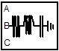

Three-Phase Series RLC Load

(v) **Three-Phase Breaker block**

The Three-Phase Breaker block implements a three-phase circuit breaker where the opening and closing times can be controlled either from an external Simulink signal or from an internal control signal.

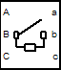

Three-Phase Breaker block

(vi) **Gain block**



Gain block

The Gain block multiplies the input by a constant value (gain). The input and the gain can each be a scalar, vector, or matrix.

**(vii) Parallel RLC Branch block**

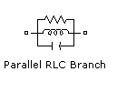

The Parallel RLC Branch block implements a single resistor, inductor, and capacitor or a parallel combination of these. Use the **Branch type** parameter to select elements you want to include in the branch. If you eliminate either the resistance, inductance, or capacitance of the branch, the R, L, and C values are automatically set respectively to infinity (inf), infinity (inf), and 0 and the corresponding parameters no longer appear in the block dialog box. Only existing elements are displayed in the block icon.

**(viii) The Series RLC Branch block**

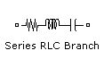

The Series RLC Branch block implements a single resistor, inductor, or capacitor, or a series combination of these. Use the Branch type parameter to select elements you want to include in the branch. If you eliminate either the resistance, inductance, or capacitance of the branch, the R, L, and C values are automatically set respectively to 0, 0, and infinity (inf) and the corresponding parameters no longer appear in the block dialog box. Only existing elements are displayed in the block icon.

**4.2. SIMULINK RESULTS:**

As per the design equations, a two phase interleaved boost converter with uncoupled, directly coupled inductors and inversely coupled inductors are simulated in MATLABI SIMULINK .The values for uncoupled mc are L=2.5mH, C=781lF ,f=2KHz.and R=3.2fl.The output voltage is Vo=38V for an input Vin=20V. The values used for directly and inversely coupled mc are summarized as Yin = 20V, R = 3.2 fl, C =78uF, fs= 2 kHz, Lm = 7mH, Lkl = Lk2 = 4.3mH, Vo =37v, D=0.5and a = 0.61 for directly coupled. Fig 5 and 6 shows inductor current ripple waveform and the output voltage waveform of uncoupled me. Figs. 7 and 8 show the inductor current ripple and output voltage waveforms of a directly coupled mc under steady-state condition. For directly coupled inductors, phase current ripple and input current ripple is lesser compared to uncoupled inductors.

**4.2.1 Directly coupled IBC:**

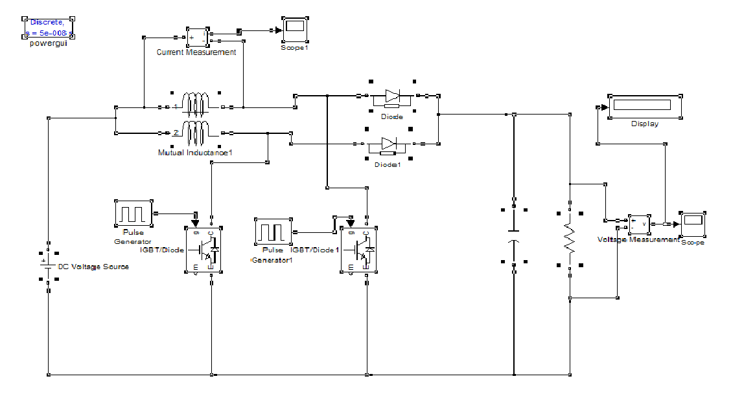

Fig 4.1 Circuit diagram directly coupled IBC

**Inductor current ripple waveform of directly coupled IBC:**

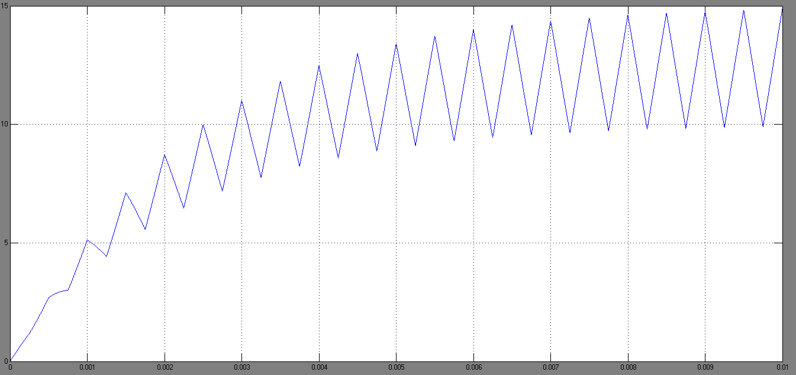

Fig 4.1(a) Inductor current ripple waveform of directly coupled IBC

**Output voltage waveforms of a directly coupled IBC:**

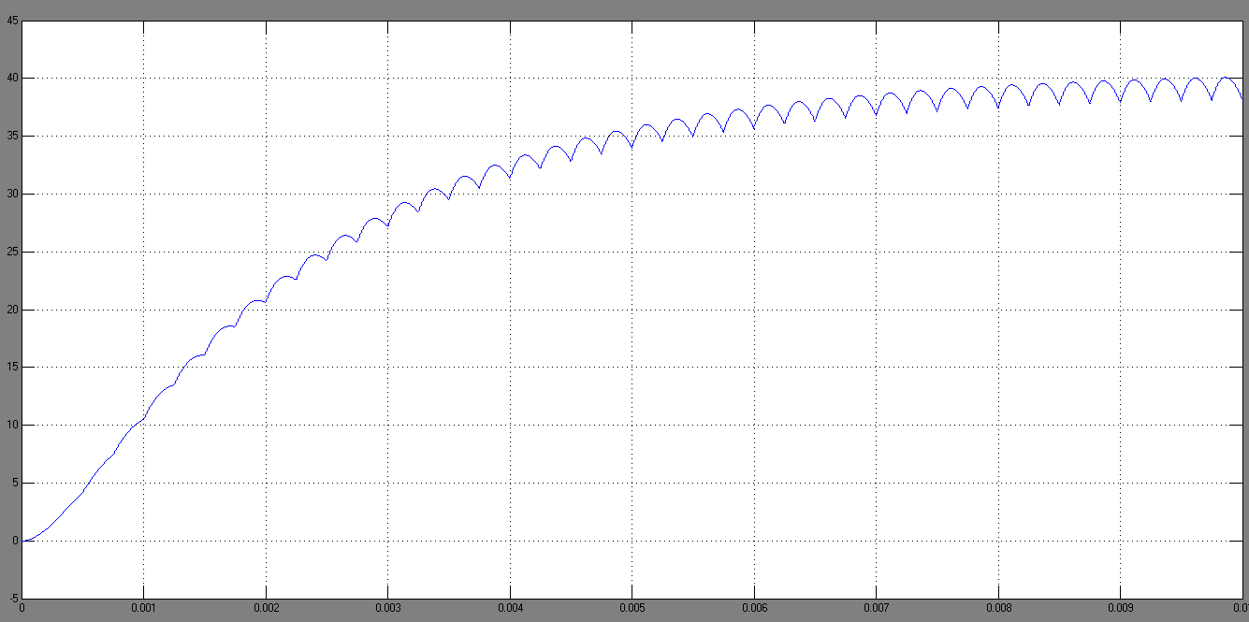

Fig 4.1(b) Output voltage waveforms of a directly coupled IBC

**4.2.2Indirectly coupled IBC:**

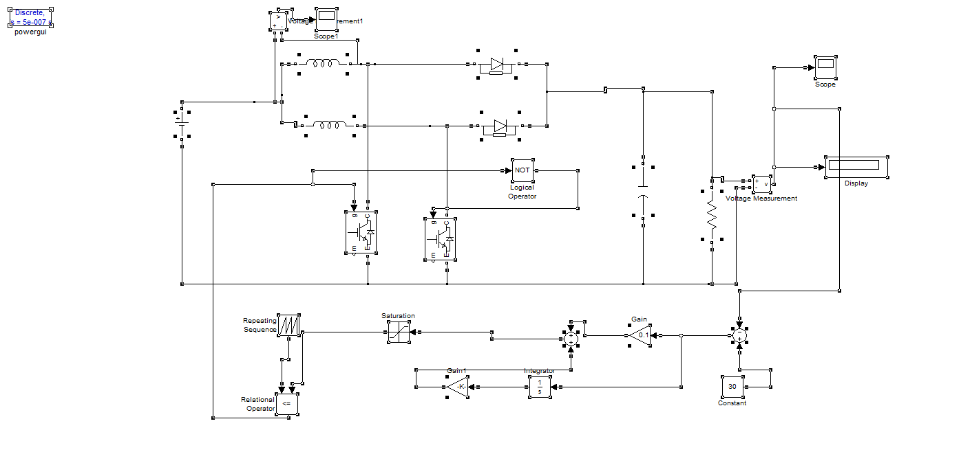

Fig 4.2 Circuit diagram of indirectly coupled IBC

**Inductor current ripple waveform of directly coupled IBC:**

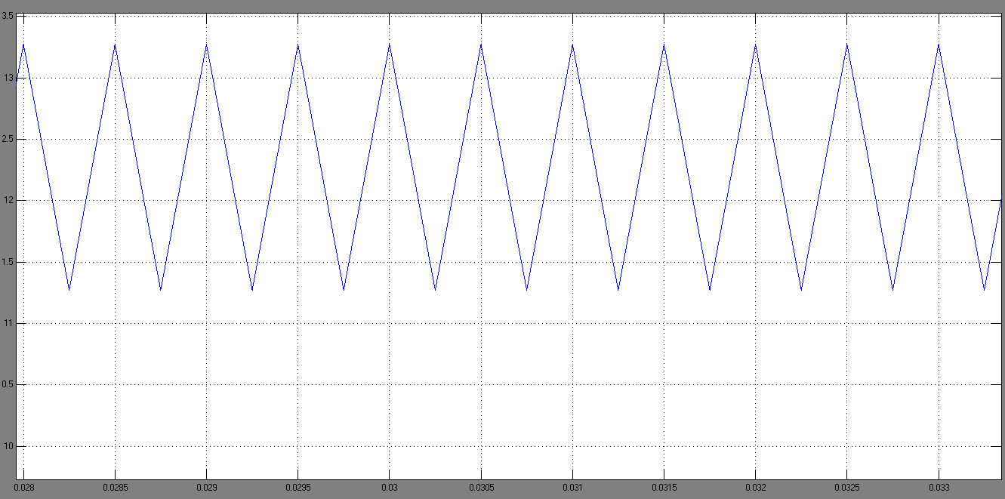

Fig 4.2(a) Inductor current ripple waveform of directly coupled IBC

**Output voltage waveforms of indirectly coupled IBC:**

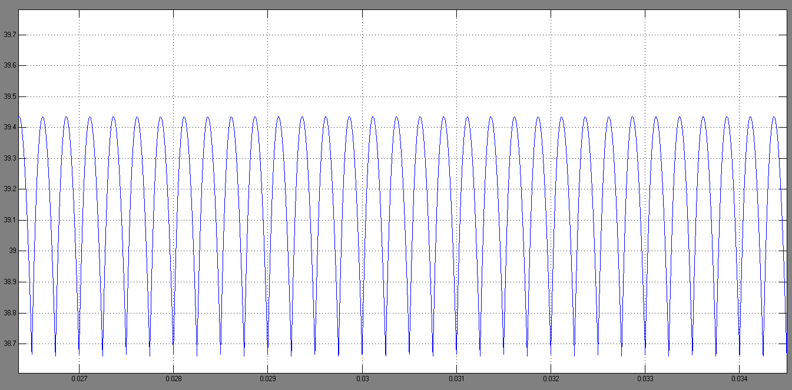

Fig 4.2(b) Output voltage waveforms of indirectly coupled IBC

**4.2.3 Inversely coupled IBC:**

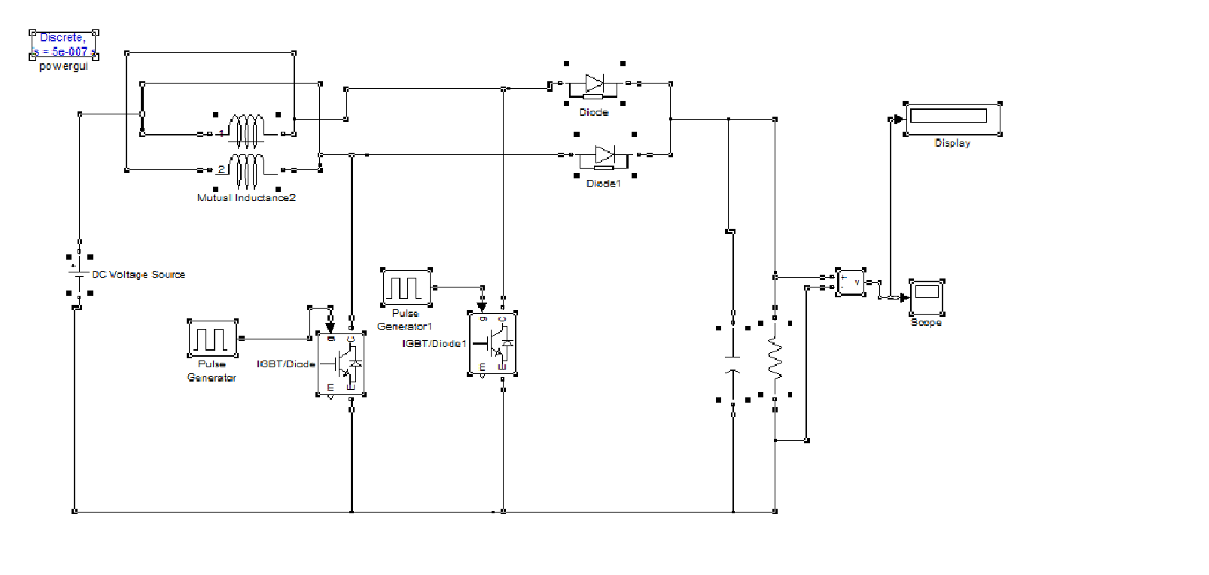

Fig 4.3 Circuit diagram Inversely Coupled IBC

**Output voltage waveforms of a inversely coupled IBC:**

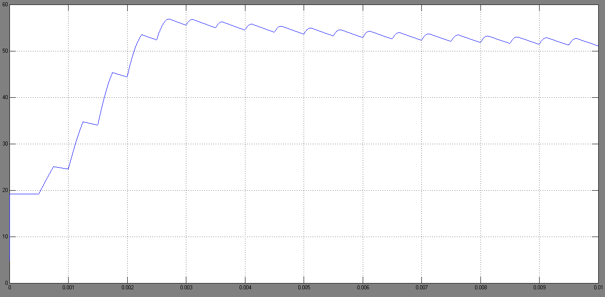

4.3(a) Output voltage waveforms of a inversely coupled IBC

**CHAPTER 5**

**CONCLUSION**

Interleaved boost converter has so many advantages and is a suitable converter for renewable energy applications. Three cases of IBC using uncoupled, coupled and inversely coupled inductor have been analyzed for renewable energy applications. Their design equations have been presented and performance parameters of all three cases have been compared using simulation. It is demonstrated that the directly coupled interleaved DC-DC converter effectively reduces the overall current ripple compared to that of uncoupled inductors. Therefore directly coupled IBC is a suitable choice for fuel cells.

**REFERENCES**

[1] Choe, G.Y; Kang,H.S; Lee, B.K; and Lee, W.L. "Design consideration of Interleaved Converters for fuel cell applications", in Proc. International conference on Electrical machines and Systems, Seoul, 2007, pp.238 -243.

[2] Kosai, H; McNeal, S; Page, .A; Jordan, B; Scofield, J; and Ray, .B. "Characterizing the effects of inductor coupling on the performance of an interleaved boost converter," in Proc. CARTS USA 2009,2009, pp. 237-251.

[3] Shin,H.B; Park,J.G; Chung, S.K; Lee, .H.W; and Lipo, T.A. "Generalized Steady-State Analysis of Multiphase Interleaved Boost Converter with Coupled Inductors," in Proc. IEE Electronics Power Application, Vol. 152, No. 3, 2005, pp. 584-594.

[4] Lee, .P; Lee, .Y; Cheng, .DKW; and Liu, X. "Steady-state analysis of an interleaved boost converter with coupled inductors", IEEE Trans. on Industrial Electronics, 47, 2000, pp. 787-795.

[5] Dahono, P.A; Riyadi, S; Mudawari, A; and Haroen, Y."Output ripple analysis of multiphase DC-DC converter", in Proc. IEEE International Conference on Power Electrical and Drive Systems, Hong Kong, 1999.

[6] Veerachary, M; Senjyu, T; and Uezato, K. "Small-signal analysis of interleaved dual boost converter", International Journal of circuit theory and applications, Vol.29, Issue 6, 2001, pp. 575 - 589.

[7] Laszlor, H; Brian, T; Irving, M; Milan and Jovanovic. "ClosedLoop Control Methods for Interleaved DCMlCCM Boundary Boost PFC Converters," in Proc. IEEE Applied Power Electronics Conference, 2009, pp. 991-997.

[8] Thounthong, P; Sethakul,P; Rael,S; and Davat,B. "Design and implementation of 2- phase interleaved boost converter for fuel cell power source," in Proc. International Conference on Power Electronics, Machines, and Drives, PEMD 2008, pp. 91-95.

[9]M.Harinee, V.S.Nagarajan, Dimple, R.Seyezhai, Dr.B.L.Mathur. "Modeling and design of fuel cell based interleaved boost converter". Electrical Energy Systems (ICEES), 2011 1st International Conference on Year: 2011, pp. 72 - 77

[10] R. Seyezhai and B.L. Mathur "Analysis, Design and Experimentation of Interleaved Boost Converter for Fuel Cell Power Source" International Journal of Research and Reviews in Information Sciences (IJRRlS) Vol. 1, No. 2, June 2011 ISSN: 2046-6439 Copyright © Science Academy Publisher, United Kingdom

[11] R.Seyezhai, "Design Consideration of Interleaved Boost Converter for Fuel Cell Systems", international journal of advanced engineering sciences and technologies, Vol No. 7, Issue

No. 2, pp. 323 - 329.

[12] P. A. Dahono, S. Riyadi, A. Mudawari, and Y. Haroen, "Output ripple analysis of multiphase DC-DC converter," IEEE Power Electr. And Drive Systems (PEDS), pp.626-631, 1999.

[13] Y. Hu et aI., "Characteristics analysis of two-channel interleaved boost converter with integrated coupling inductors," in Proc. IEEE Power Electronics Specialists Con!, Jun. 2006.

[14] Xu, .H; Qiao, .E; Guo, .X; Wen, .X; and Kong, L. "Analysis and Design of High Power Interleaved Boost Converters for Fuel Cell Distributed Generation System", in Proc. IEEE Power.

[15] Wai, R.J; and Duan; .R.Y. "High step-up converter with coupled-inductor," IEEE Trans. Power Electronics, Vol. 20, No.5, pp. 1025-1035,2005.

[16] Huber, L; Brian, T; Irving, and Jovanovic, .M.M. "ClosedLoop Control Methods for Interleaved DCMlCCM Boundary Boost PFC Converters," in Proc. IEEE Applied Power Electronics Conference and Exposition, APEC 2009, pp. 991-997, 2009.